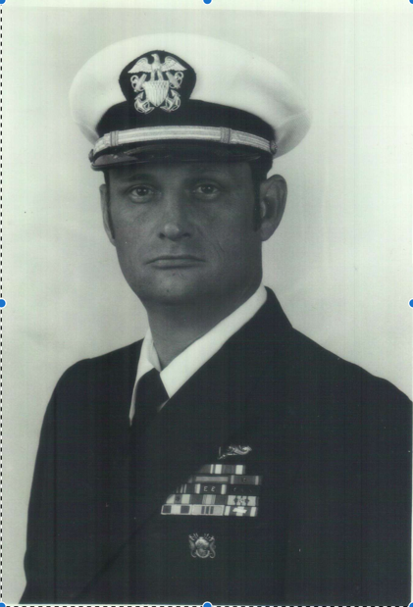
Oscar Clyde Westbrook
December 15, 1947 – June 27, 2024
Oscar Clyde Westbrook, age 76, of Youngstown, Florida, passed away on June 27, 2024. He was born on December 15, 1947, in Biloxi, Mississippi, to his birth parents, Mary and Otto Pounds, and was later adopted by M.L. and Brentice Westbrook.
Oscar proudly served his country for 30 years in the United States Navy, retiring with the esteemed rank of Chief Warrant Officer and qualified as a Master Diver and Saturation Diver. His distinguished military career was marked by his leadership in executing high-stakes, national-level missions, many of which were authorized by Presidential directive. These missions, often conducted in times of conflict, involved strategic operations that were critical to national security. His mastery of diving and underwater operations—particularly as a Saturation Diver, capable of conducting extended missions at extreme depths—positioned him as a key figure in the Navy's elite dive teams, and he played a vital role in the successful completion of classified assignments across the globe.
His unwavering dedication and exceptional performance earned him numerous awards and commendations, reflecting the high regard in which he was held by his superiors and peers. In addition to his operational achievements, Oscar furthered his knowledge by earning an Associate of Science degree in Nuclear Science Technology from Georgia Military College.
While serving in the Navy, Oscar discovered a passion for archery that would stay with him for over 30 years. What began as a simple interest grew into a meaningful part of his life, as he participated in various tournaments and competitions, earning a solid reputation in the archery community. For Oscar, archery was more than just a hobby; it brought him joy and satisfaction.
In addition to archery, Oscar was an avid outdoorsman who enjoyed hunting with both bow and rifle. He shared his love for nature with his daughter and grandchildren, creating cherished memories during their time spent together outdoors. Oscar and his beloved wife, Nancy, took many cross-country trips, often bringing their grandchildren along to explore the beauty of the country together.
Oscar is preceded in death by his birth parents, Mary and Otto Pounds; adoptive parents, M.L. and Brentice Westbrook; brother, Paul Batia; sisters, Vicki Batia and Susan Pounds King; and brother, Danny Pounds. He is survived by his loving wife, Nancy Westbrook; daughter, Jamie (Hughie) Henderson; grandchildren, Cheyenne Westbrook and Sharyn Henderson; sisters, Mary Ann Batia, Lorraine (Randy) Stutts, and Sylvia (Danny) McDavid; along with several cousins, nephews, and nieces.

